SQL and NoSQL

1-✅ What is SQL?
# Source: AI Source: Provided by: [Data Path: Persons Table -> ID Column: 1, Name_En Column: Motasem Essam] -> From: [ChatGPT] on [6/10/2026]
SQL stands for Structured Query Language. It's used to interact with relational databases.

🔹 Key Features:
# Source: AI Source: Provided by: [Data Path: Persons Table -> ID Column: 1, Name_En Column: Motasem Essam] -> From: [ChatGPT] on [6/10/2026]
- Table-based (data stored in rows and columns)
- Uses schemas (fixed structure)
- Supports ACID properties (Atomicity, Consistency, Isolation, Durability)
- Great for complex queries and structured data

🧱 Examples of SQL Databases:
# Source: AI Source: Provided by: [Data Path: Persons Table -> ID Column: 1, Name_En Column: Motasem Essam] -> From: [ChatGPT] on [6/10/2026]
- MySQL
- PostgreSQL
- SQLite
- Oracle Database
- Microsoft SQL Server

📝 Common SQL Commands:
# Source: AI Source: Provided by: [Data Path: Persons Table -> ID Column: 1, Name_En Column: Motasem Essam] -> From: [ChatGPT] on [6/10/2026]
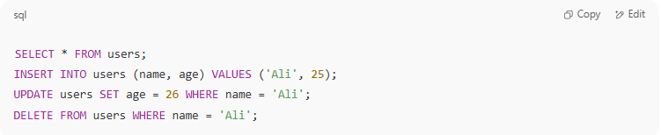
SELECT * FROM users;
INSERT INTO users (name, age) VALUES ('Ali', 25);
UPDATE users SET age = 26 WHERE name = 'Ali';
DELETE FROM users WHERE name = 'Ali';

2-✅ What is NoSQL?
# Source: AI Source: Provided by: [Data Path: Persons Table -> ID Column: 1, Name_En Column: Motasem Essam] -> From: [ChatGPT] on [6/10/2026]
NoSQL stands for "Not Only SQL" and refers to non-relational databases that store data in flexible formats.

🔹 Key Features:
# Source: AI Source: Provided by: [Data Path: Persons Table -> ID Column: 1, Name_En Column: Motasem Essam] -> From: [ChatGPT] on [6/10/2026]
- Flexible schema or schema-less
- Designed for scalability and speed
- Often used for unstructured, semi-structured, or rapidly changing data
- Prioritizes availability and partition tolerance over strict consistency (CAP theorem)

🧰 Types of NoSQL Databases:
# Source: AI Source: Provided by: [Data Path: Persons Table -> ID Column: 1, Name_En Column: Motasem Essam] -> From: [ChatGPT] on [6/10/2026]
- Document-based: MongoDB, CouchDB
(Stores JSON-like documents)
- Key-Value stores: Redis, DynamoDB
(Stores data as key–value pairs)
- Column-based: Apache Cassandra, HBase
(Stores data in columns instead of rows)
- Graph-based: Neo4j
(Best for relationships, like social networks)

🗂️ 1. Document-Based Databases
# Source: AI Source: Provided by: [Data Path: Persons Table -> ID Column: 1, Name_En Column: Motasem Essam] -> From: [ChatGPT] on [6/10/2026]
🧠 Think of it like storing each record as a mini-JSON file.

🔸 Description:
# Source: AI Source: Provided by: [Data Path: Persons Table -> ID Column: 1, Name_En Column: Motasem Essam] -> From: [ChatGPT] on [6/10/2026]
Document-based databases store data as documents, usually in formats like JSON, BSON, or XML. Each document contains key-value pairs and can have nested structures.

📌 Features:
# Source: AI Source: Provided by: [Data Path: Persons Table -> ID Column: 1, Name_En Column: Motasem Essam] -> From: [ChatGPT] on [6/10/2026]
- Schema-less: Documents can have different structures
- Ideal for storing complex, hierarchical data
- Easily maps to objects in code (object-document mapping)
- Great for agile development and frequent changes

🔧 Common Use Cases:
# Source: AI Source: Provided by: [Data Path: Persons Table -> ID Column: 1, Name_En Column: Motasem Essam] -> From: [ChatGPT] on [6/10/2026]
- Content management systems
- Catalogs, blogs
- User profiles with varying fields

🌟 Examples:

✅ MongoDB:
# Source: AI Source: Provided by: [Data Path: Persons Table -> ID Column: 1, Name_En Column: Motasem Essam] -> From: [ChatGPT] on [6/10/2026]
- Most popular document database
- Uses BSON (Binary JSON)
- Rich querying and indexing
- Easily scalable with replica sets and sharding
MongoDB Document Example:
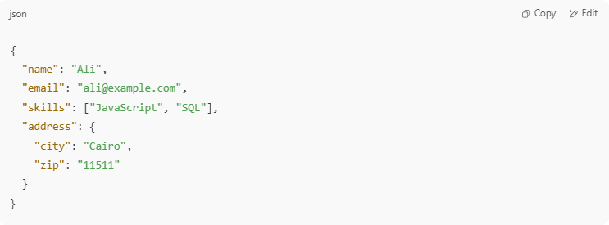
{
"name": "Ali",
"email": "ali@example.com",
"skills": ["JavaScript", "SQL"],
"address": {
"city": "Cairo",
"zip": "11511"
}
}

✅ CouchDB:
# Source: AI Source: Provided by: [Data Path: Persons Table -> ID Column: 1, Name_En Column: Motasem Essam] -> From: [ChatGPT] on [6/10/2026]
- Uses JSON and HTTP for communication (RESTful)
- Strong replication and offline syncing (great for mobile apps)
- Built-in web-based UI: Futon

🔑 2. Key-Value Stores
# Source: AI Source: Provided by: [Data Path: Persons Table -> ID Column: 1, Name_En Column: Motasem Essam] -> From: [ChatGPT] on [6/10/2026]
🧠 Like a super-fast dictionary (key → value).

🔸 Description:
# Source: AI Source: Provided by: [Data Path: Persons Table -> ID Column: 1, Name_En Column: Motasem Essam] -> From: [ChatGPT] on [6/10/2026]
Each item is stored as a pair:
- Key: unique identifier
- Value: data (can be string, JSON, binary, etc.)
Simple and lightning-fast.

📌 Features:
# Source: AI Source: Provided by: [Data Path: Persons Table -> ID Column: 1, Name_En Column: Motasem Essam] -> From: [ChatGPT] on [6/10/2026]
- Blazing speed for read/write operations
- Very simple structure (no joins or queries)
- Best for caching, session storage, and real-time apps

🔧 Common Use Cases:
# Source: AI Source: Provided by: [Data Path: Persons Table -> ID Column: 1, Name_En Column: Motasem Essam] -> From: [ChatGPT] on [6/10/2026]
- Session management
- Caching (e.g., user login sessions)
- Shopping cart storage
- Real-time leaderboards

🌟 Examples:

✅ Redis:
# Source: AI Source: Provided by: [Data Path: Persons Table -> ID Column: 1, Name_En Column: Motasem Essam] -> From: [ChatGPT] on [6/10/2026]
- In-memory store (super fast)
- Supports complex data types (lists, sets, hashes)
- Often used as a cache or message broker
Redis Key-Value Example:
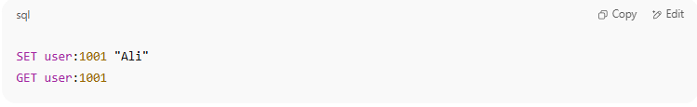
SET user:1001 "Ali"
GET user:1001

✅ Amazon DynamoDB:
# Source: AI Source: Provided by: [Data Path: Persons Table -> ID Column: 1, Name_En Column: Motasem Essam] -> From: [ChatGPT] on [6/10/2026]
- Fully managed NoSQL database by AWS
- Highly scalable and distributed
- Supports both key-value and document formats
- Great for serverless apps

📊 3. Column-Based Databases
# Source: AI Source: Provided by: [Data Path: Persons Table -> ID Column: 1, Name_En Column: Motasem Essam] -> From: [ChatGPT] on [6/10/2026]
🧠 Think Excel, but optimized for reading columns instead of rows.

🔸 Description:
# Source: AI Source: Provided by: [Data Path: Persons Table -> ID Column: 1, Name_En Column: Motasem Essam] -> From: [ChatGPT] on [6/10/2026]
Stores data in columns instead of rows. Each column family contains rows with a key and set of columns.
Better for aggregating and analyzing large amounts of data.

📌 Features:
# Source: AI Source: Provided by: [Data Path: Persons Table -> ID Column: 1, Name_En Column: Motasem Essam] -> From: [ChatGPT] on [6/10/2026]
- High performance for read-heavy and write-heavy workloads
- Excellent for time-series data
- Scales horizontally across many servers
- Flexible schemas

🔧 Common Use Cases:
# Source: AI Source: Provided by: [Data Path: Persons Table -> ID Column: 1, Name_En Column: Motasem Essam] -> From: [ChatGPT] on [6/10/2026]
- Time-series analysis
- Event logging
- IoT applications
- Analytics dashboards

🌟 Examples:

✅ Apache Cassandra:
# Source: AI Source: Provided by: [Data Path: Persons Table -> ID Column: 1, Name_En Column: Motasem Essam] -> From: [ChatGPT] on [6/10/2026]
- Decentralized (no master node)
- Extremely scalable
- Used by Netflix, Instagram, and Uber
Cassandra Data Example:
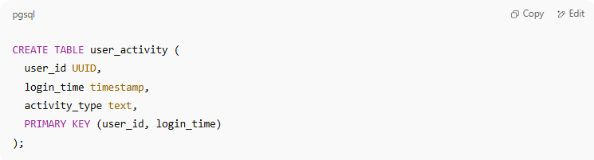
CREATE TABLE user_activity (
user_id UUID,
login_time timestamp,
activity_type text,
PRIMARY KEY (user_id, login_time)
);

✅ HBase:
# Source: AI Source: Provided by: [Data Path: Persons Table -> ID Column: 1, Name_En Column: Motasem Essam] -> From: [ChatGPT] on [6/10/2026]
- Built on top of Hadoop’s HDFS
- Great for massive datasets
- Tight integration with Hadoop ecosystem

🔗 4. Graph-Based Databases
# Source: AI Source: Provided by: [Data Path: Persons Table -> ID Column: 1, Name_En Column: Motasem Essam] -> From: [ChatGPT] on [6/10/2026]
🧠 Best for showing relationships — like Facebook friends or flight routes.

🔸 Description:
# Source: AI Source: Provided by: [Data Path: Persons Table -> ID Column: 1, Name_En Column: Motasem Essam] -> From: [ChatGPT] on [6/10/2026]
Uses nodes, edges, and properties to represent and store data. Nodes = entities (like people), edges = relationships.

📌 Features:
# Source: AI Source: Provided by: [Data Path: Persons Table -> ID Column: 1, Name_En Column: Motasem Essam] -> From: [ChatGPT] on [6/10/2026]
- Designed for deep relationships
- Fast traversal and pathfinding
- Schema flexible
- Visual query tools (great for data exploration)

🔧 Common Use Cases:
# Source: AI Source: Provided by: [Data Path: Persons Table -> ID Column: 1, Name_En Column: Motasem Essam] -> From: [ChatGPT] on [6/10/2026]
- Social networks
- Recommendation engines
- Fraud detection
- Knowledge graphs

🌟 Example:

✅ Neo4j:
# Source: AI Source: Provided by: [Data Path: Persons Table -> ID Column: 1, Name_En Column: Motasem Essam] -> From: [ChatGPT] on [6/10/2026]
- Most popular graph database
- Uses Cypher Query Language (like SQL for graphs)
Neo4j Example:
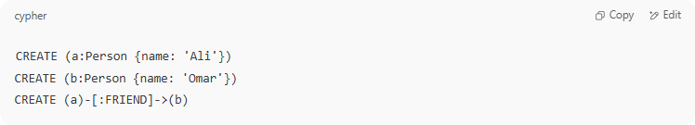
CREATE (a:Person {name: 'Ali'})
CREATE (b:Person {name: 'Omar'})
CREATE (a)-[:FRIEND]->(b)

- Query to find friends of Ali:
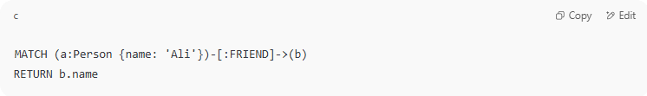
MATCH (a:Person {name: 'Ali'})-[:FRIEND]->(b)
RETURN b.name

✅ Summary Table
# Source: AI Source: Provided by: [Data Path: Persons Table -> ID Column: 1, Name_En Column: Motasem Essam] -> From: [ChatGPT] on [6/10/2026]
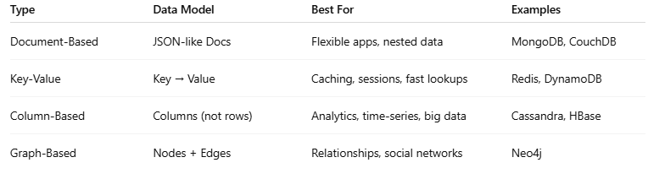
Type | Data Model | Best For | Examples
Document-Based | JSON-like Docs | Flexible apps, nested data | MongoDB, CouchDB
Key-Value | Key → Value | Caching, sessions, fast lookups | Redis, DynamoDB
Column-Based | Columns (not rows) | Analytics, time-series, big data | Cassandra, HBase
Graph-Based | Nodes + Edges | Relationships, social networks | Neo4j

🧾 Example (MongoDB document):
# Source: AI Source: Provided by: [Data Path: Persons Table -> ID Column: 1, Name_En Column: Motasem Essam] -> From: [ChatGPT] on [6/10/2026]
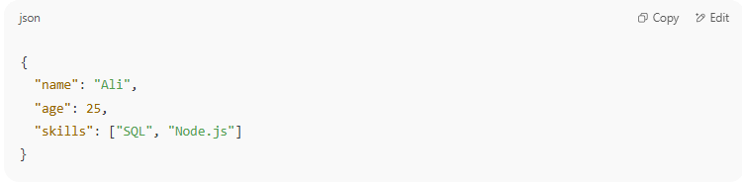
{
"name": "Ali",
"age": 25,
"skills": ["SQL", "Node.js"]
}

⚖️ SQL vs NoSQL Summary
# Source: AI Source: Provided by: [Data Path: Persons Table -> ID Column: 1, Name_En Column: Motasem Essam] -> From: [ChatGPT] on [6/10/2026]

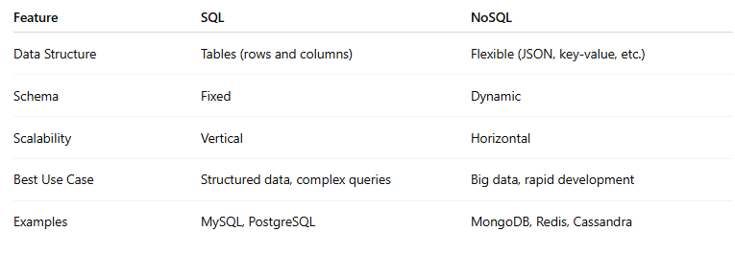
Feature | SQL | NoSQL
Data Structure | Tables (rows and columns) | Flexible (JSON, key-value, etc.)
Schema | Fixed | Dynamic
Scalability | Vertical | Horizontal
Best Use Case | Structured data, complex queries | Big data, rapid development
Examples | MySQL, PostgreSQL | MongoDB, Redis, Cassandra

